**Name: Luca Novello Student Number: 038515003**

|  |  |  |  |  |
| --- | --- | --- | --- | --- |
| **Learning Goal**  I want to learn…. | **Strategy**  I will learn by… | **What Success May Look Like**  Accomplishing my goal may look like… | **Target Date** | **Post Co-op/Work Term Evidence of Success**  **Note:** This is to be completed after your work term and it is for your own reflection. This section can also be a part of your discussion in the mid-term site visit |
| **EXAMPLE:**  *I want to learn more about different programming languages that were not extensively focused on or covered in class and be able to apply them during my work term on various projects and working alongside my new team members.* | *I will learn by engaging in self learning.*  *I will use my research skills and various online resources to learn and practice the programming languages that I am not familiar with as they will become a great asset to me during my work term and career.* | *Accomplishing this goal will be demonstrating my newly acquired skills and programming languages in various projects at my workplace.*  *Accomplishing my goal may also require me to take initiative and offer to work on projects where these new languages are being used to test my skills.* | *July 1, 2019 (halfway through my work term)* | *I have developed a strategy to learn new programming languages on my own and can learn them quickly.*  *I have illustrated and demonstrated at least one new programming language successfully and according to company standards in my workplace and/or with my colleagues on a particular project.* |
| GOAL #1:  I want to learn more about diagnosing, troubleshooting, documenting and monitoring technical problems using appropriate methodologies and tools so to better integrate and work with my team. | I will use my research skills and use online resources and tutorials to learn more about different software and methodologies that my team is using. | After accomplishing this goal will, I will be able to demonstrate a good understanding of both the methodologies used, as well as different software and tools used to review code. | Feb 1, 2025  (*roughly a month into my work term*) |  |

**INDIVIDUALIZED LEARNING PLAN - TEMPLATE**

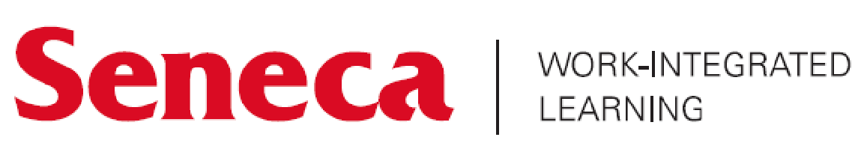Use the template below to develop an individualized learning plan for your co-op/work term. This learning plan should reflect what you would like to achieve during your co-op/work term and how you will attain your goals. If you have secured a role, reviewing the job description of your position will help you develop these learning goals. If you have not yet secured a role, think of a potential job within your field of study and identify specific skills and goals you would like to attain using the knowledge you have gained throughout your program (these goals should then be updated once you have secured your co-op/work term to reflect your actual role and goals).

Include at least four (4) goals in your learning plan, with one (1) goal being a program learning outcome for your academic program of study (refer to your academic program page on Seneca’s website to review your program learning outcomes).

|  |  |  |  |  |
| --- | --- | --- | --- | --- |
| **Learning Goal**  I want to learn…. | **Strategy**  I will learn by… | **What Success May Look Like**  Accomplishing my goal may look like… | **Target Date** | **Post Co-op/Work Term Evidence of Success**  **Note:** This is to be completed after your work term and it is for your own reflection. This section can also be a part of your discussion in the mid-term site visit |
| GOAL #2:  I want to be able to communicate and collaborate with team members and stakeholders to ensure effective working relationships. | I will try to build relationships with both team members and stakeholders that will allow me to better understand how I am able to be a productive part of the team. | Accomplishing this goal will be me demonstrating that I can both receive and communicate information with my team and stakeholders, as well as acting on that information in a productive manner. | Jan 23, 2025  (*a few weeks after starting the work term*) |  |
| GOAL #3:  I want to design, develop, document, implement, maintain and test software systems by using industry standard software development methodologies based on defined specifications and existing technologies/frameworks, to better meet new business demands. | I will self research which industry standard software development methodologies and frameworks my team is using or looking into using in the future. This will allow me to better integrate with my team both in current development and with future projects. | Accomplishing this goal will mean that I am able to functionally use a range of different standard software development methodologies and frameworks to be able to be a productive member of my team. | March 1, 2025  (*halfway through my work term*) |  |
| GOAL #4:  I want to be able to select and apply object-oriented and other design concepts and principles, as well as business requirements, to the software development process. This will allow for me to meet business needs while building robust software solutions. | I will self research and use online resources to learn more about object-oriented and other design concepts and principles. I will stay up to date with my team’s business requirements and find ways to best incorporate the two. | Accomplishing this goal will mean demonstrating the ability to use various OOP concepts and design principles, to build out solutions for my team that integrate well into the existing environment. | March 1, 2025  (*halfway through my work term*) |  |